

Name: Samama Iqbal
Roll no: 2024-cet-16
Department:Software Engineering
Program:Cet
Subject : WWD
Lab:02
Submitted to : Engr.Sidra Rafique

Cpp file:

<html>
<h1> This is heading 1</h1>
<h2> This is heading 2</h2>
<h3> This is heading 3</h3>
<h4> This is heading 4</h4>
<h5> This is heading 5</h5>
<h6> This is heading 6</h6>
<br>
<p>
I am Samama iqbal <br>
From 4th semester<br>
Dept of Software Engineering<br>
2024-CET-16<br>
</p>
<br>
<table>
<table border="5">
<tr>
<th>
Movie
</th>
<th>
Year
</th>
</tr>
<tr>
<td>
Taare Zameen par
</td>
<td>
2007
</td>
</tr>
<br>
<table><br>
<table border="5" width=" 100">
<tr>
<th> Class </th>
<th>
Time
</th>
</tr>
<tr>
<td>
Web design & development
</td>
<td>
9am-11am
</td>
</tr>
</table><br>
<img src="D:\WHATSAPP\ref.png" alt="image not found"width="100">
</html>

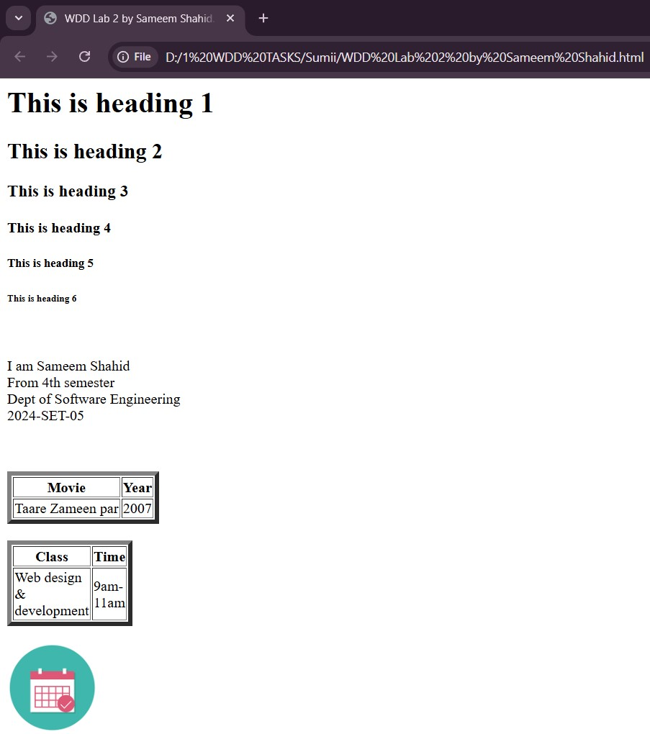
Output:

I am samama Iqbal
From 4rth semester
Dept of Software Engineering
2024-cet-16

